**IIT MANDI CS-207 APPLIED DATABASE PRACTICUM FALL 2019**

ASSIGNMENT 4: Understanding Joins, Stored Procedure and Cursors

(In groups of 4-5 students containing B. Tech. 2nd years)

**Dr. Varun Dutt Due: Before 12:00 NOON on September 30th, 2019**

**Readings:**

* Class notes and slides from week 4 and 5
* Activity 4 and 5 on Moodle

**Objectives:**

* Understand how Join works
* Understand how stored procedures works
* Understand how cursors work

**Submission:**

Each group will make one single submission.

Please submit as a zipped file, the following content:

* + Submit a .docx/.doc/.odt /.txt/.sql file containing the code.
  + Also submit the mysql dump files.

**Assignment:**

Q1. In this question load the database from the dump file (join.sql) given in moodle

The Database has the following tables:

* Customers: stores customer’s data.
* Products: stores a list of scale model cars.
* ProductLines: stores a list of product line categories.
* Orders: stores sales orders placed by customers.
* OrderDetails: stores sales order line items for each sales order.
* Payments: stores payments made by customers based on their accounts.
* Employees: stores all employee information as well as the organization structure such as who reports to whom.
* Offices: stores sales office data.

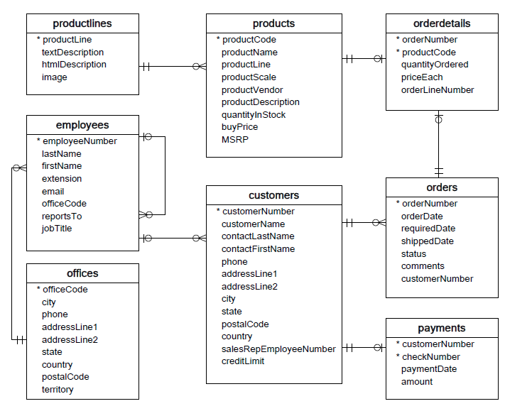

1. Find the total quantity (**orderdetails table**) ordered by each customer (**customer table**) for different orders (**orders table**).
2. List the names of the customers (**customer table**) who have made no orders (**orders table**)
3. Show the employee name (**employees table**) and the number of customers (**customers table**) of each employee in descending order.
4. List the name of the Products (**products table)** ordered by the customer **“Muscle Machine Inc”** (**customers table**).
5. List the number of times each product (**products table**) has been ordered.
6. Display the product (**products table**) which has never been ordered by any customer (**customers table**).

Q2. Load the dump file (Assignment 4) uploaded in moodle

i) Find the average Mark of students in all exams

ii) Find the maximum mark of each student in all exams

iii) Find the maximum mark of each month for all students

iv) Find the average mark of each month for all students

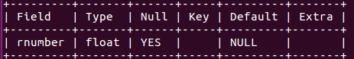Q2. Create a table **Number** similar to the schema given above. Then create a stored procedure that will insert *‘n*’ random numbers (floats) into the table **Number.** The value of *‘n’* is given by the user.

Q3. Create a stored procedure that sums the even numbers between 1 and x where x is given by the user.

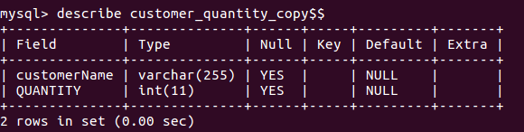Q4)

(i) Create a table named **customer_quantity_copy** with the following schema:

ii) Create a stored procedure that used a cursor that fetches the total orders (**orderdetails** table) placed by each customer (**customers** table) and store it in the **customer_quantity_copy** table.